**Experiment 6C:** **Building The Ci/Cd Scripted Pipeline Using Jenkins For Maven Java Project With Poll SCM**

* N Anand Sai(22BD1A6615)

Step 1: Go to Jenkins dashboard, click on New Item, give a name, select Pipeline and click on “OK”.

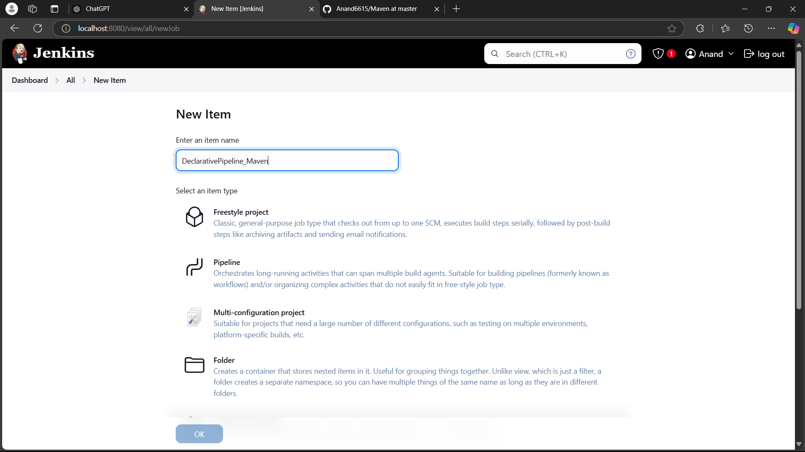

Step 2: Paste the Pipeline scripts and provide your project name and the repo link. Click on Apply -> Save.

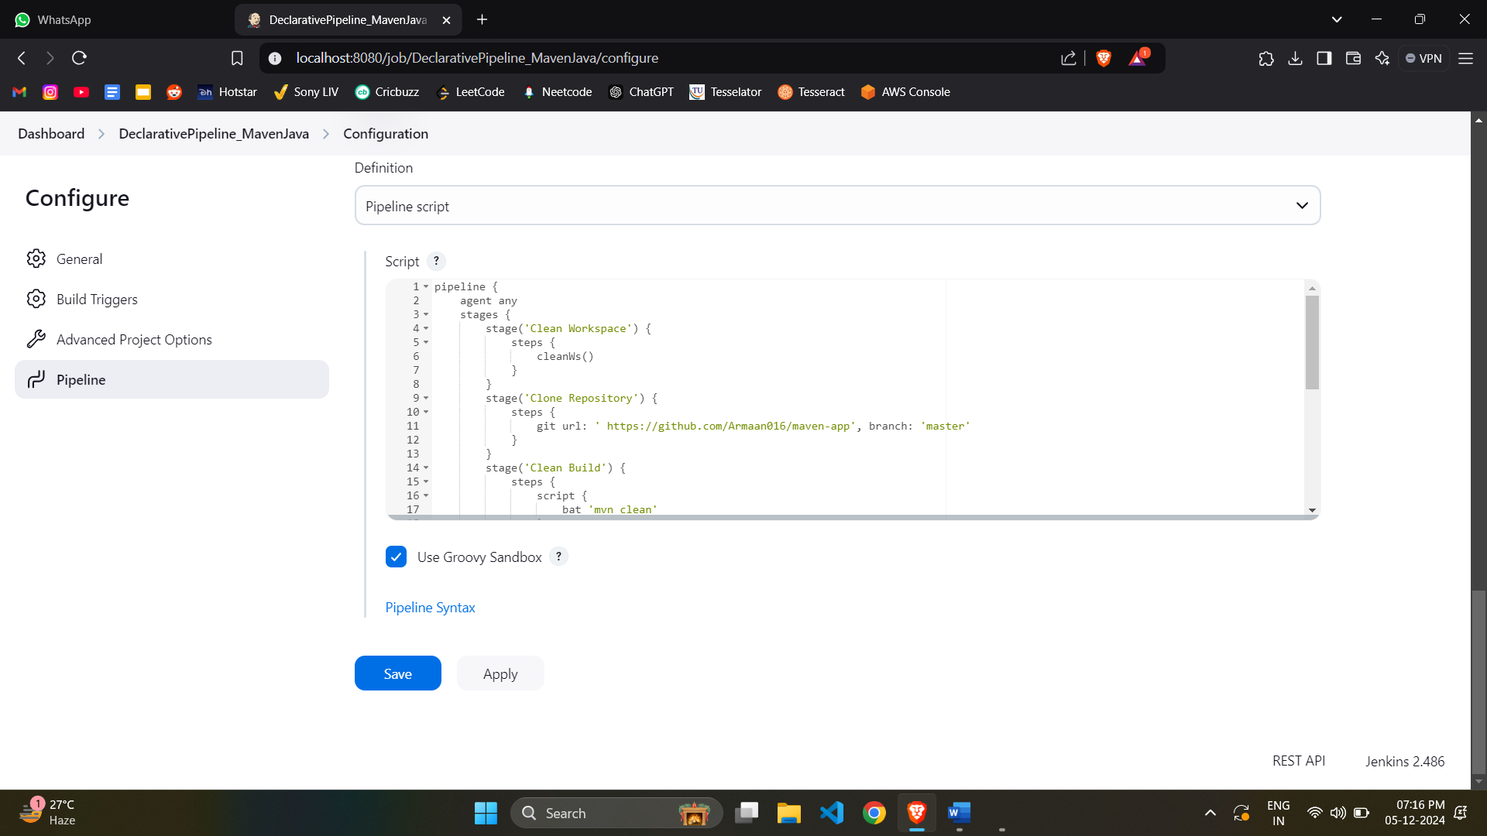

Step 3: Click on Build Now, you should see this screen.

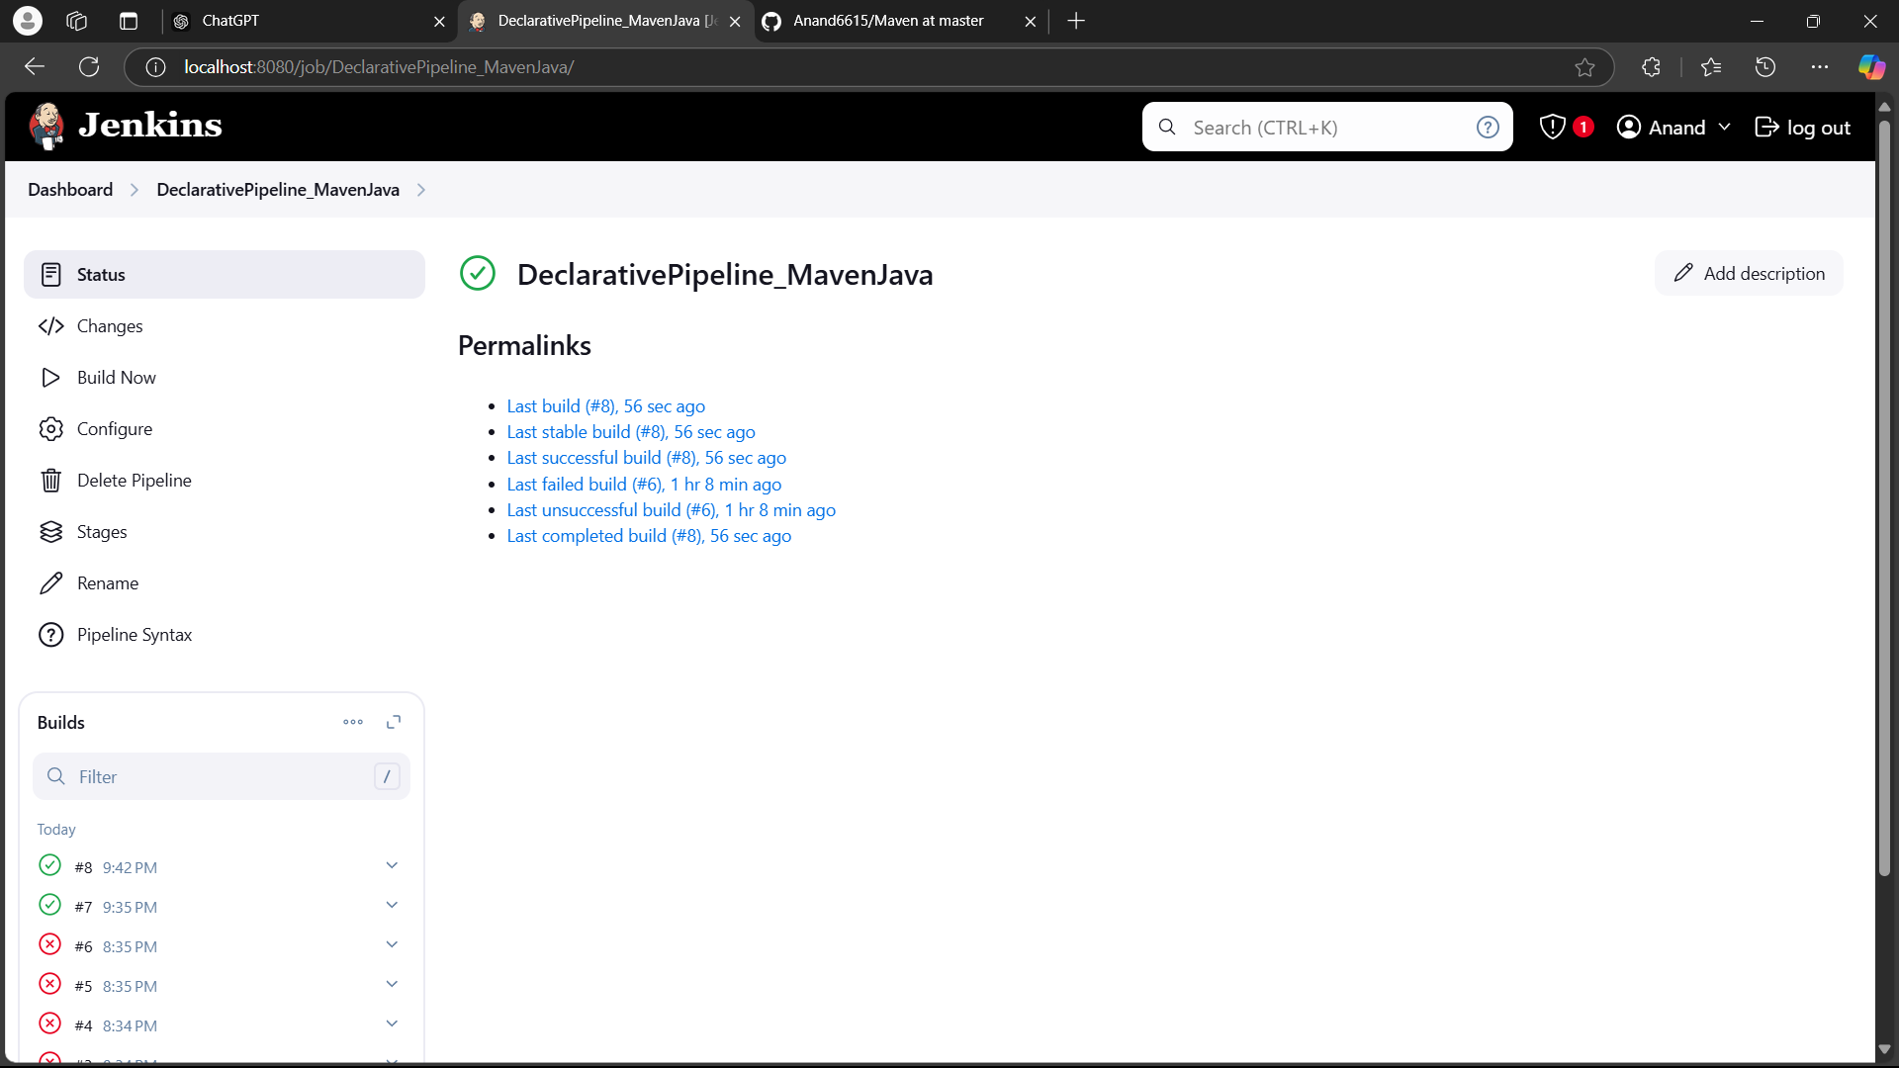

Step 4: Go to Configure -> Build periodically, enter the following in schedule. The build happens every 15 minutes now.

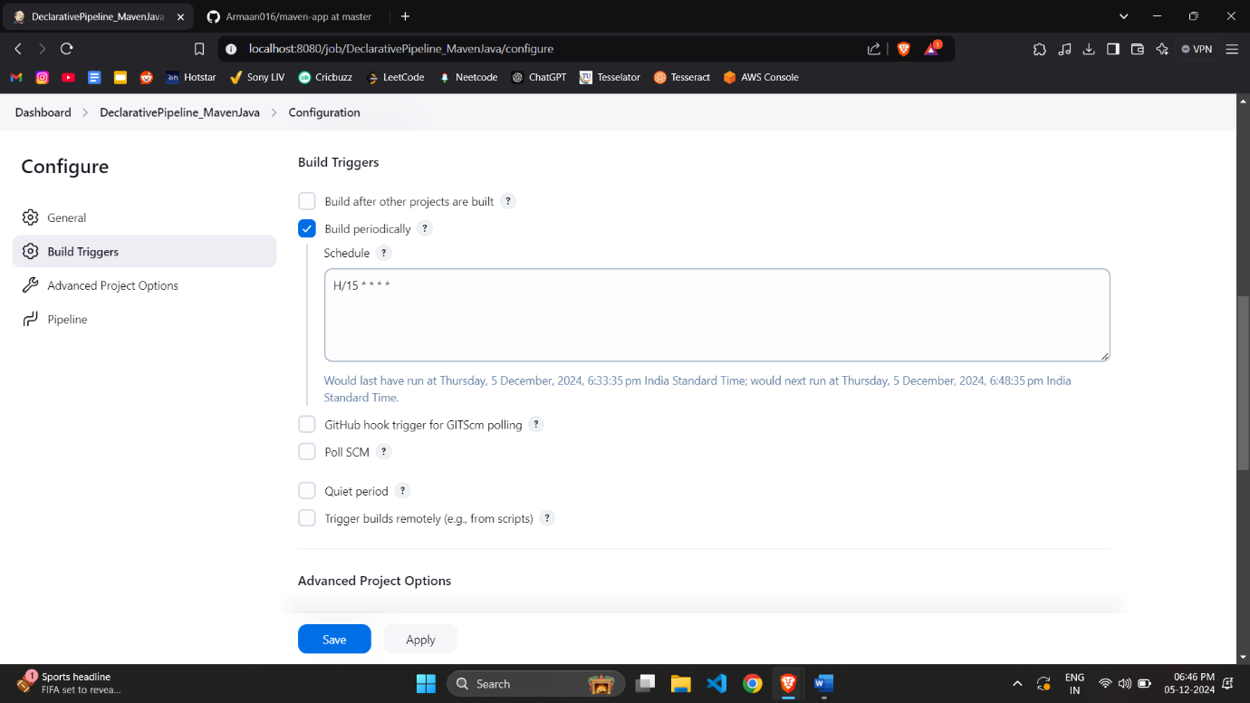

Step 5: Click on Apply -> Save. You should see this in Pipeline Overview.

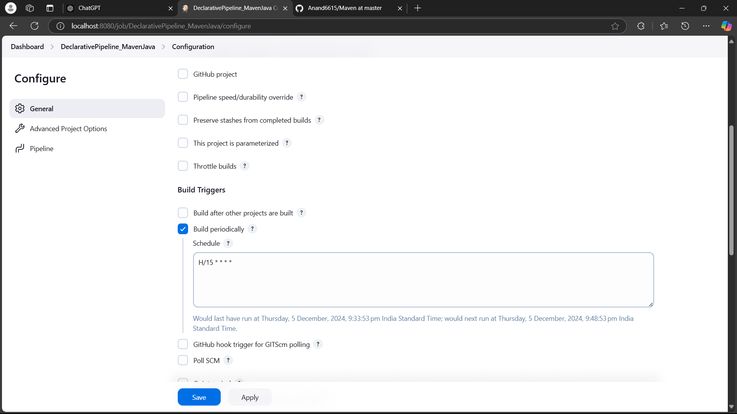

**Docker Installation and Docker Hub account creation**

Step 1: Go to docs.docker.com, and select the appropriate version for your system.

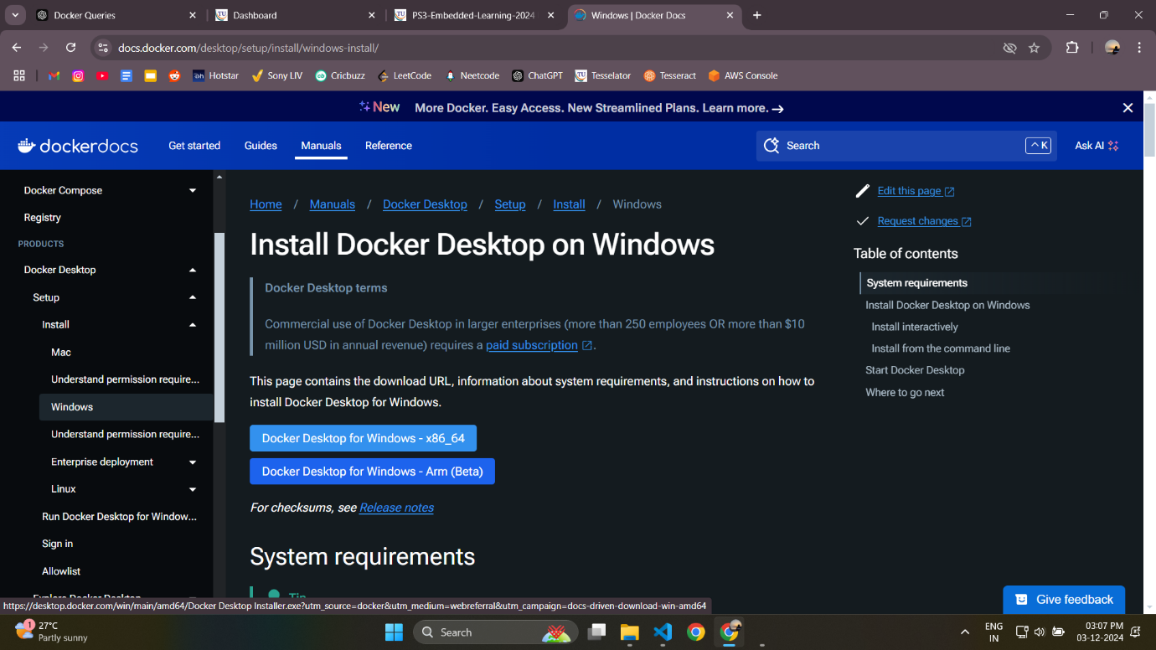

Step 2: Double click on the Docker Desktop Installer in Downloads to begin installation.

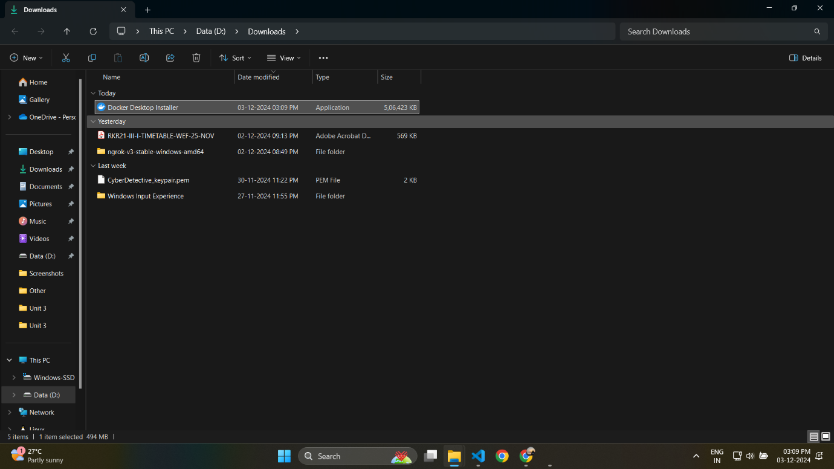

Step 3: It will show this screen. Wait until installation is complete. Click on Close and Log Out after it is complete.

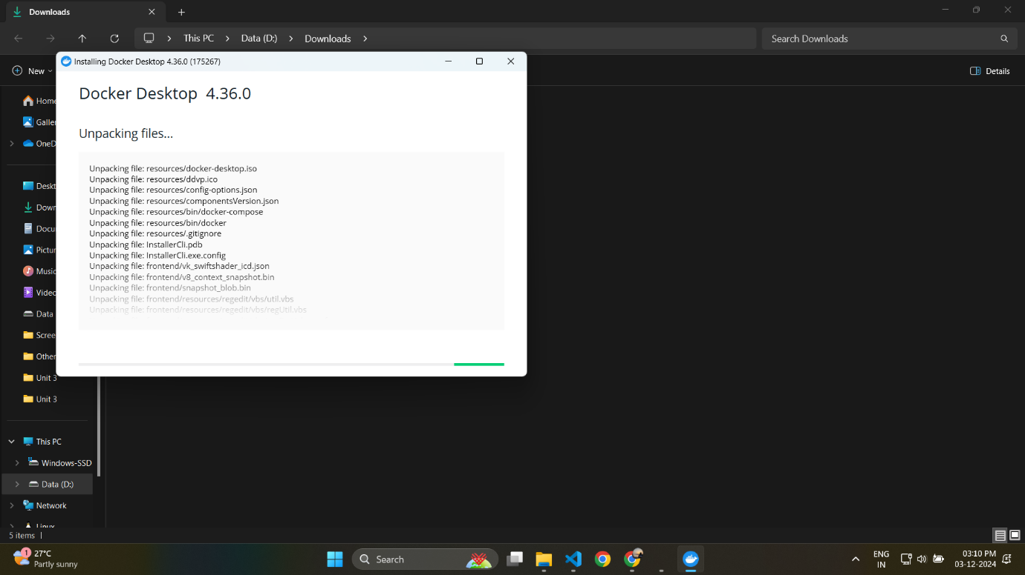

Step 4: Now open Docker Desktop.

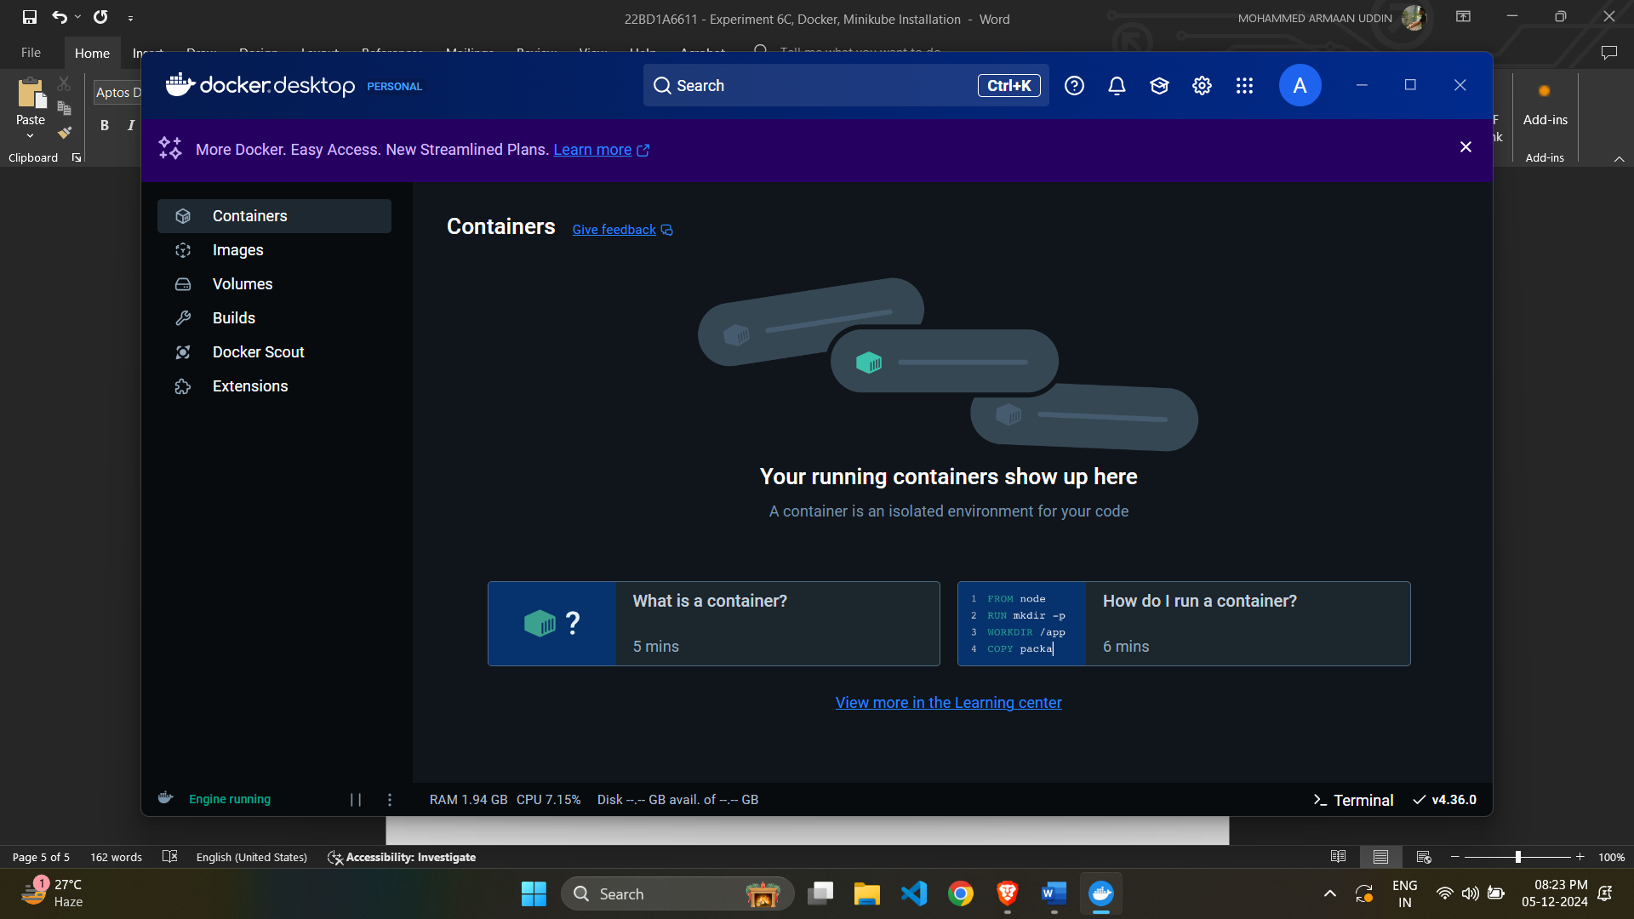

Step 5: If you don’t have WSL2 installed, follow these steps:

* Download WSL2 as shown

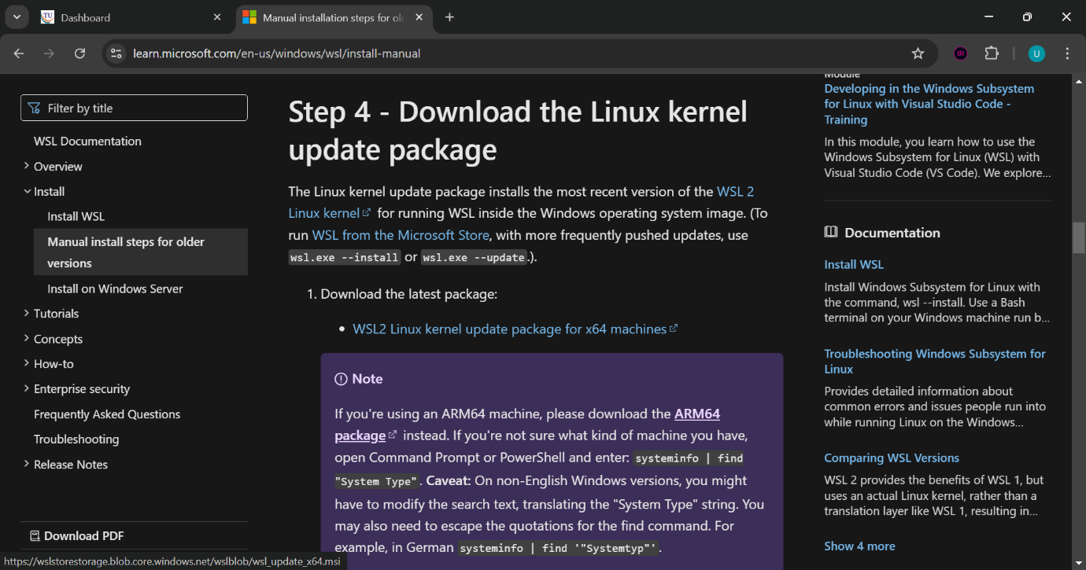

* Double click the executable file and click next as shown

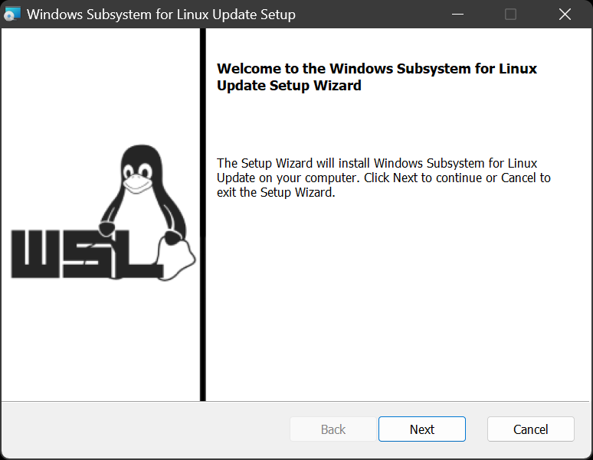

* Installation of WSL2 begins

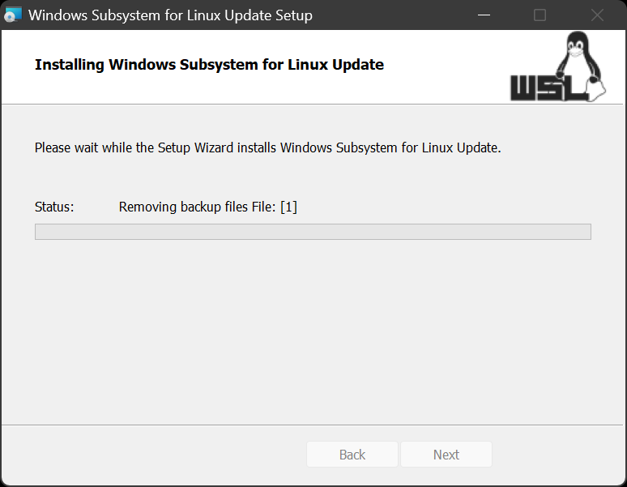

* Once the installation is completed click on Finish



Step 6: To create a docker hub account, go to hub.docker.com -> Sign Up and enter your details.

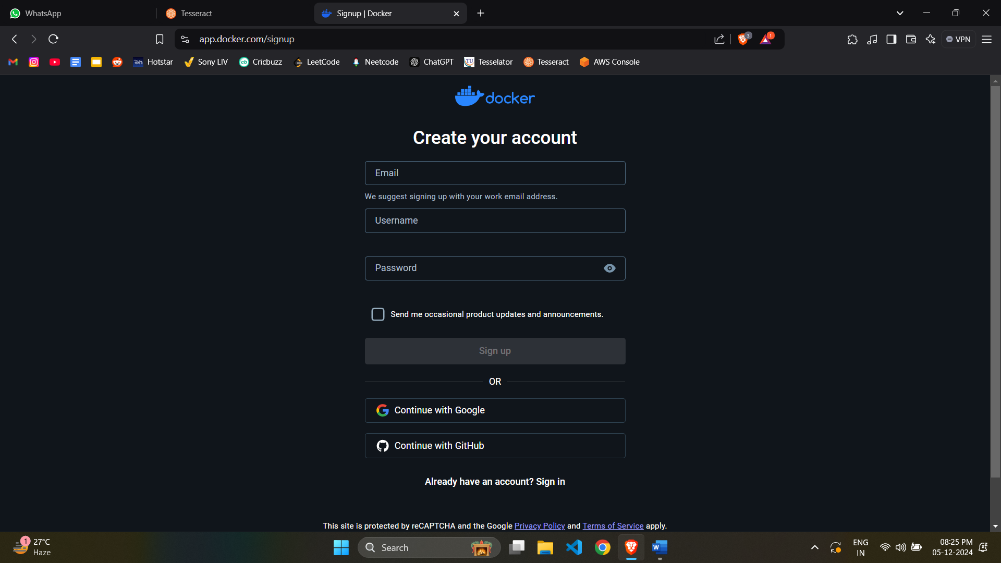

You will see the following screen after successfully logging in:

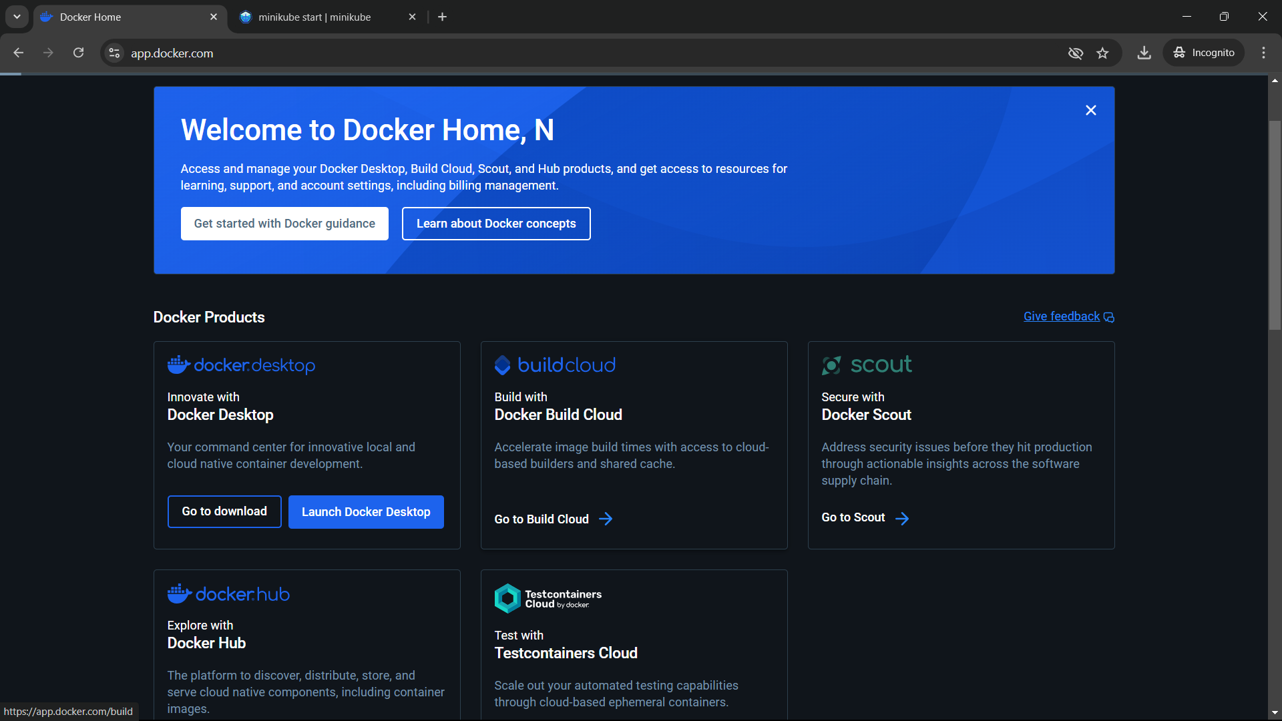

Step 7: Open command prompt as administrator and run “docker run hello-world command”.

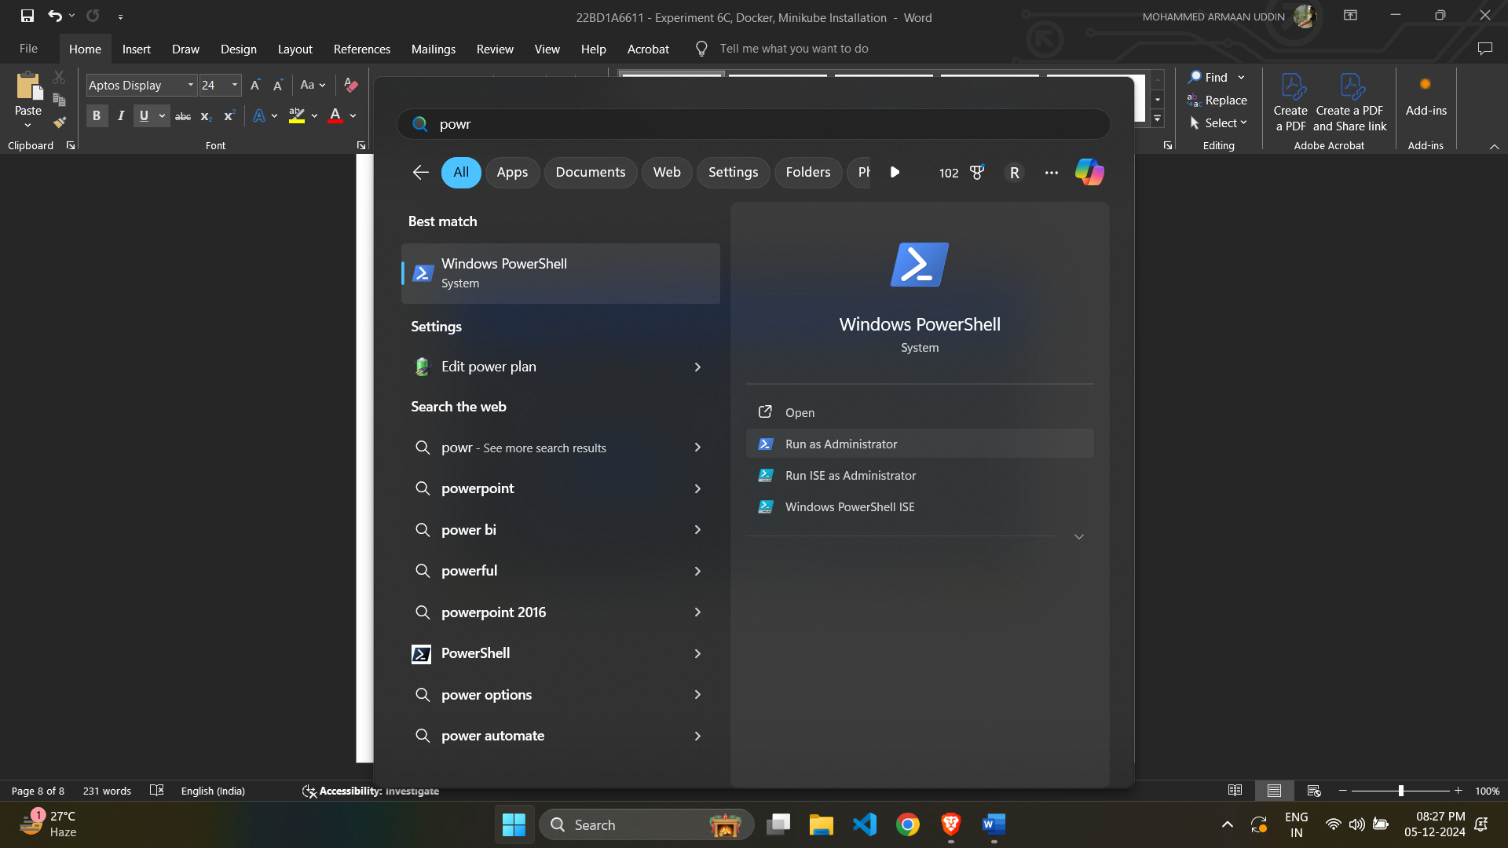

You will see the followings screen on success.

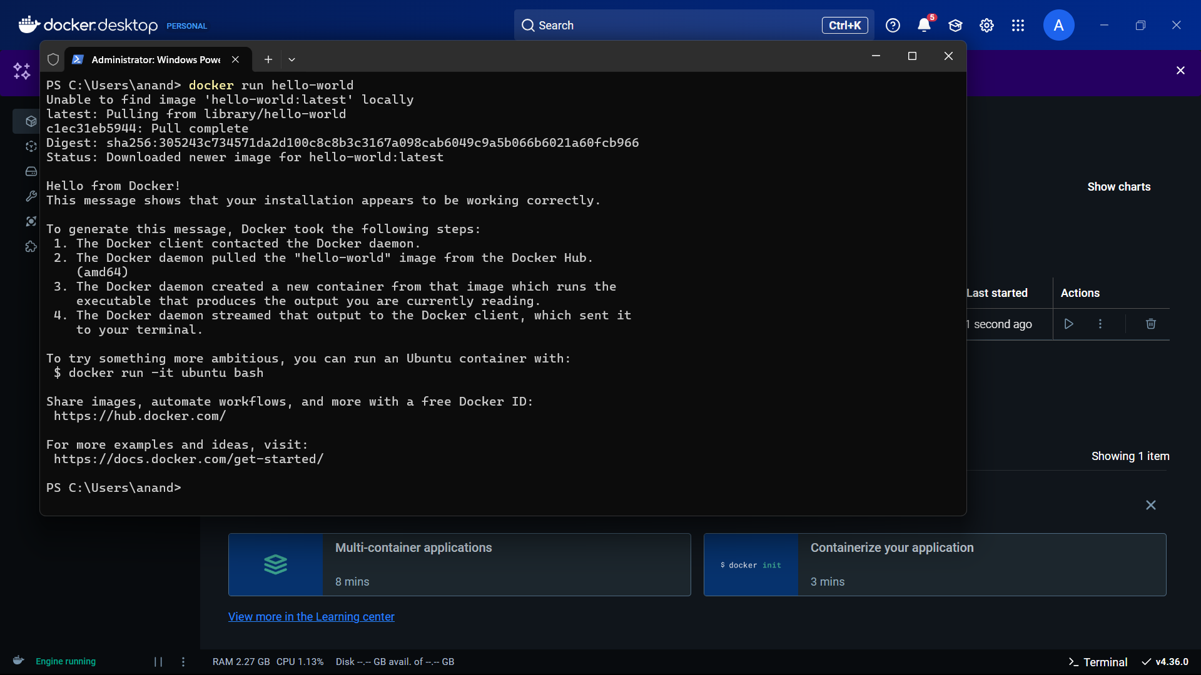

Container is now created in Docker Desktop.

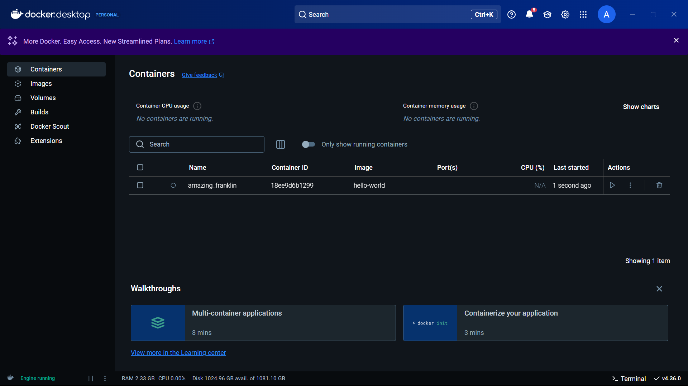

**Minikube Installation**

Step 1: Go to <https://minikube.sigs.k8s.io/docs/start/?arch=%2Fwindows%2Fx86-64%2Fstable%2F.exe+download> and select the appropriate installer based on your Operating System.

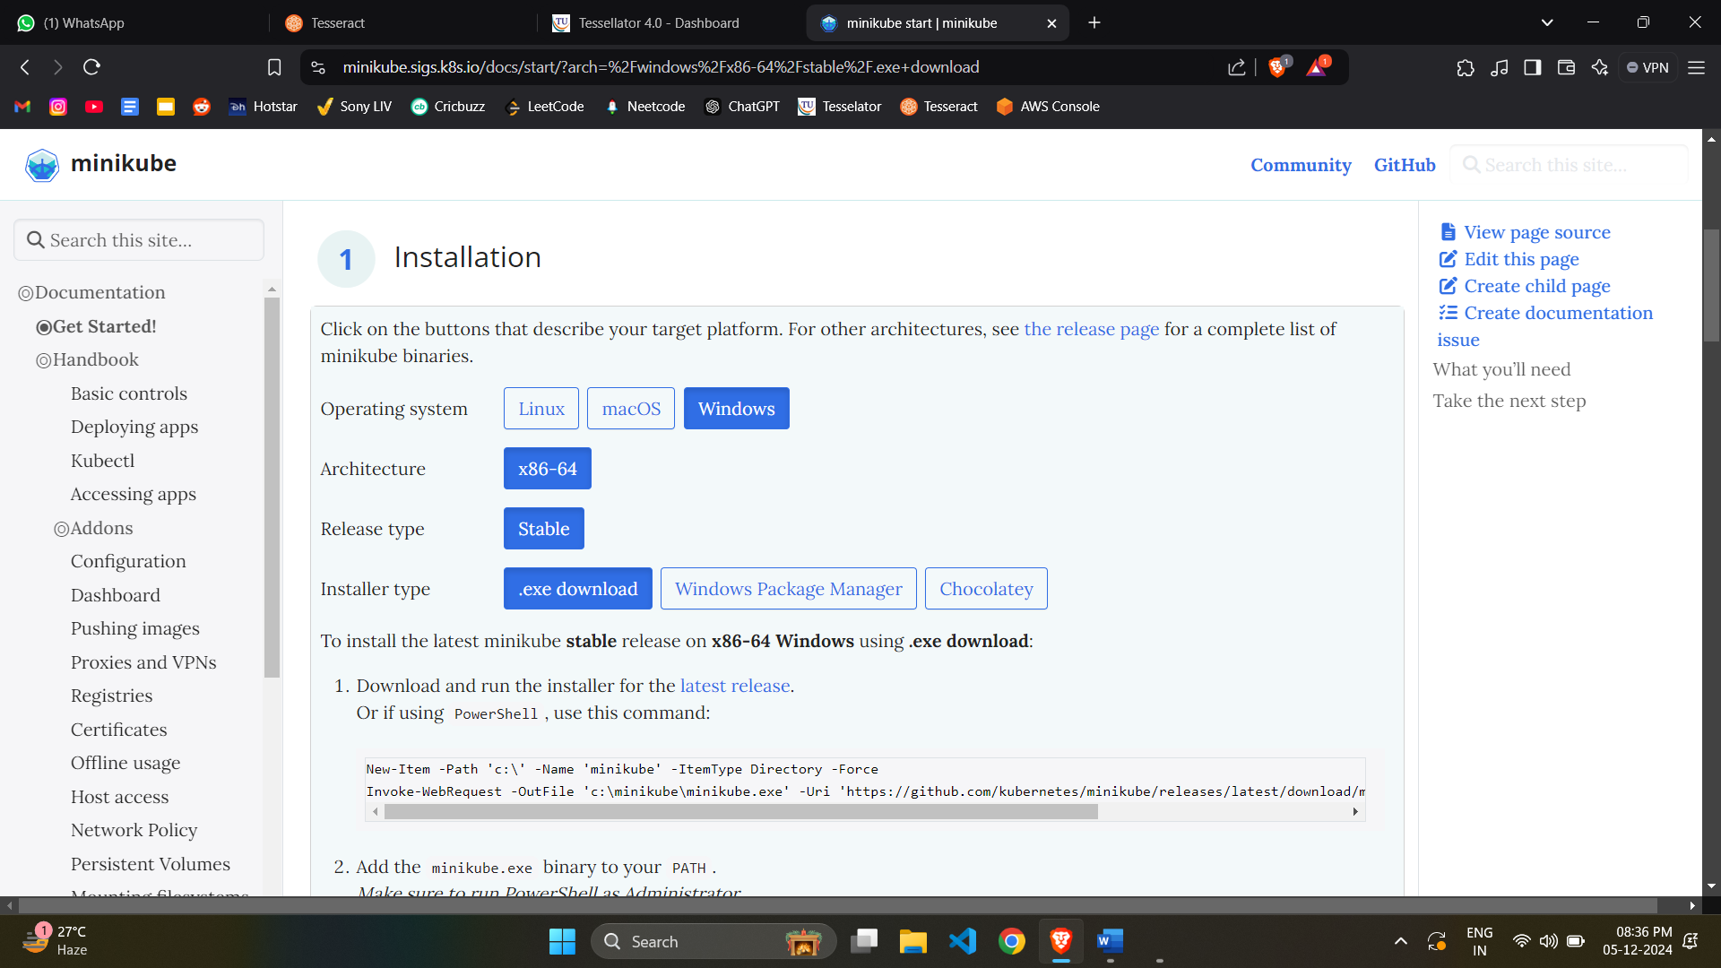

Step 2: Now run the minikube installer present in the Downloads folder.

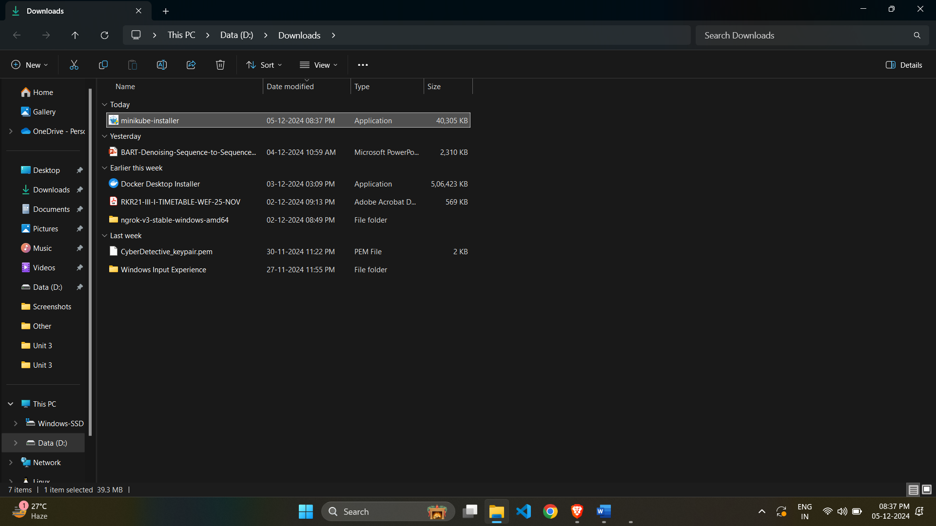

Step 3: Now, select the language, click on Next, and select the installation directory as prompted.

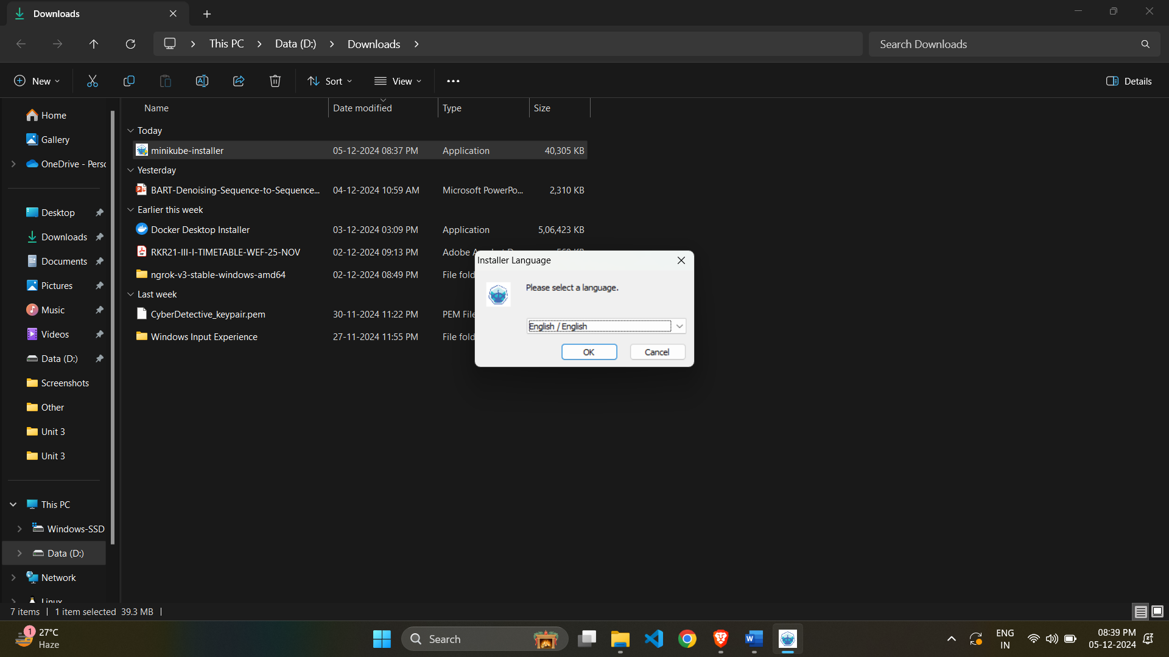

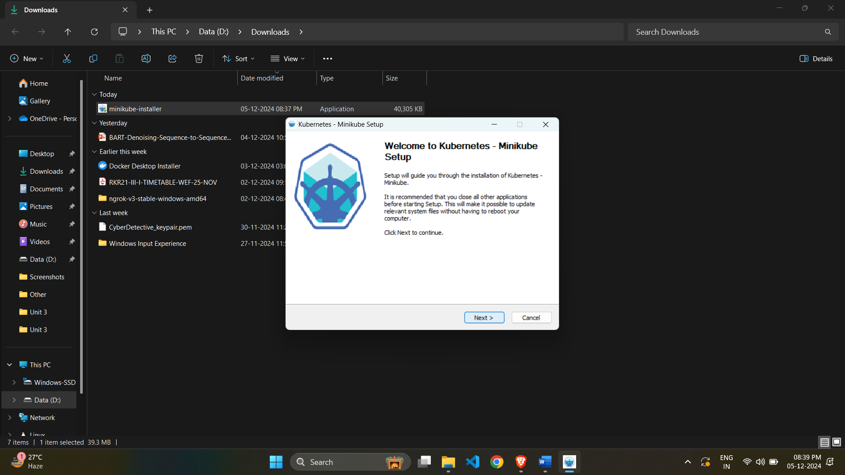

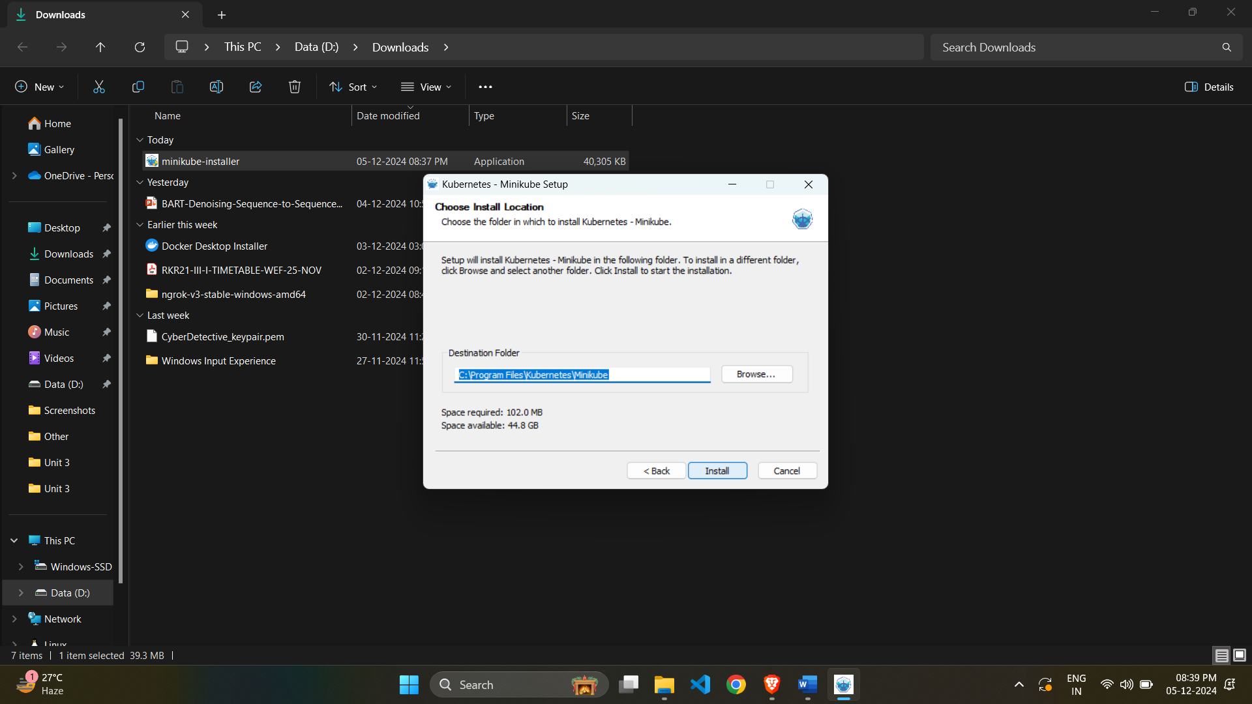

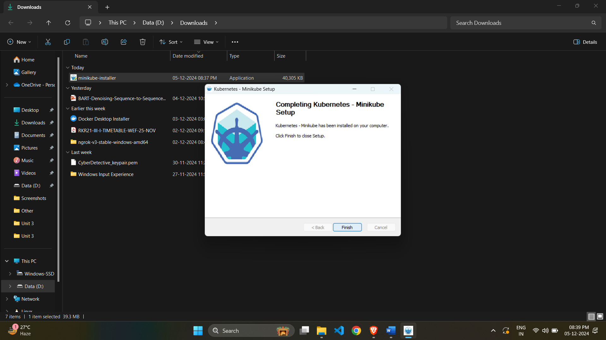

Step 4: Now open command prompt in Administrator mode and run “minikube start”.



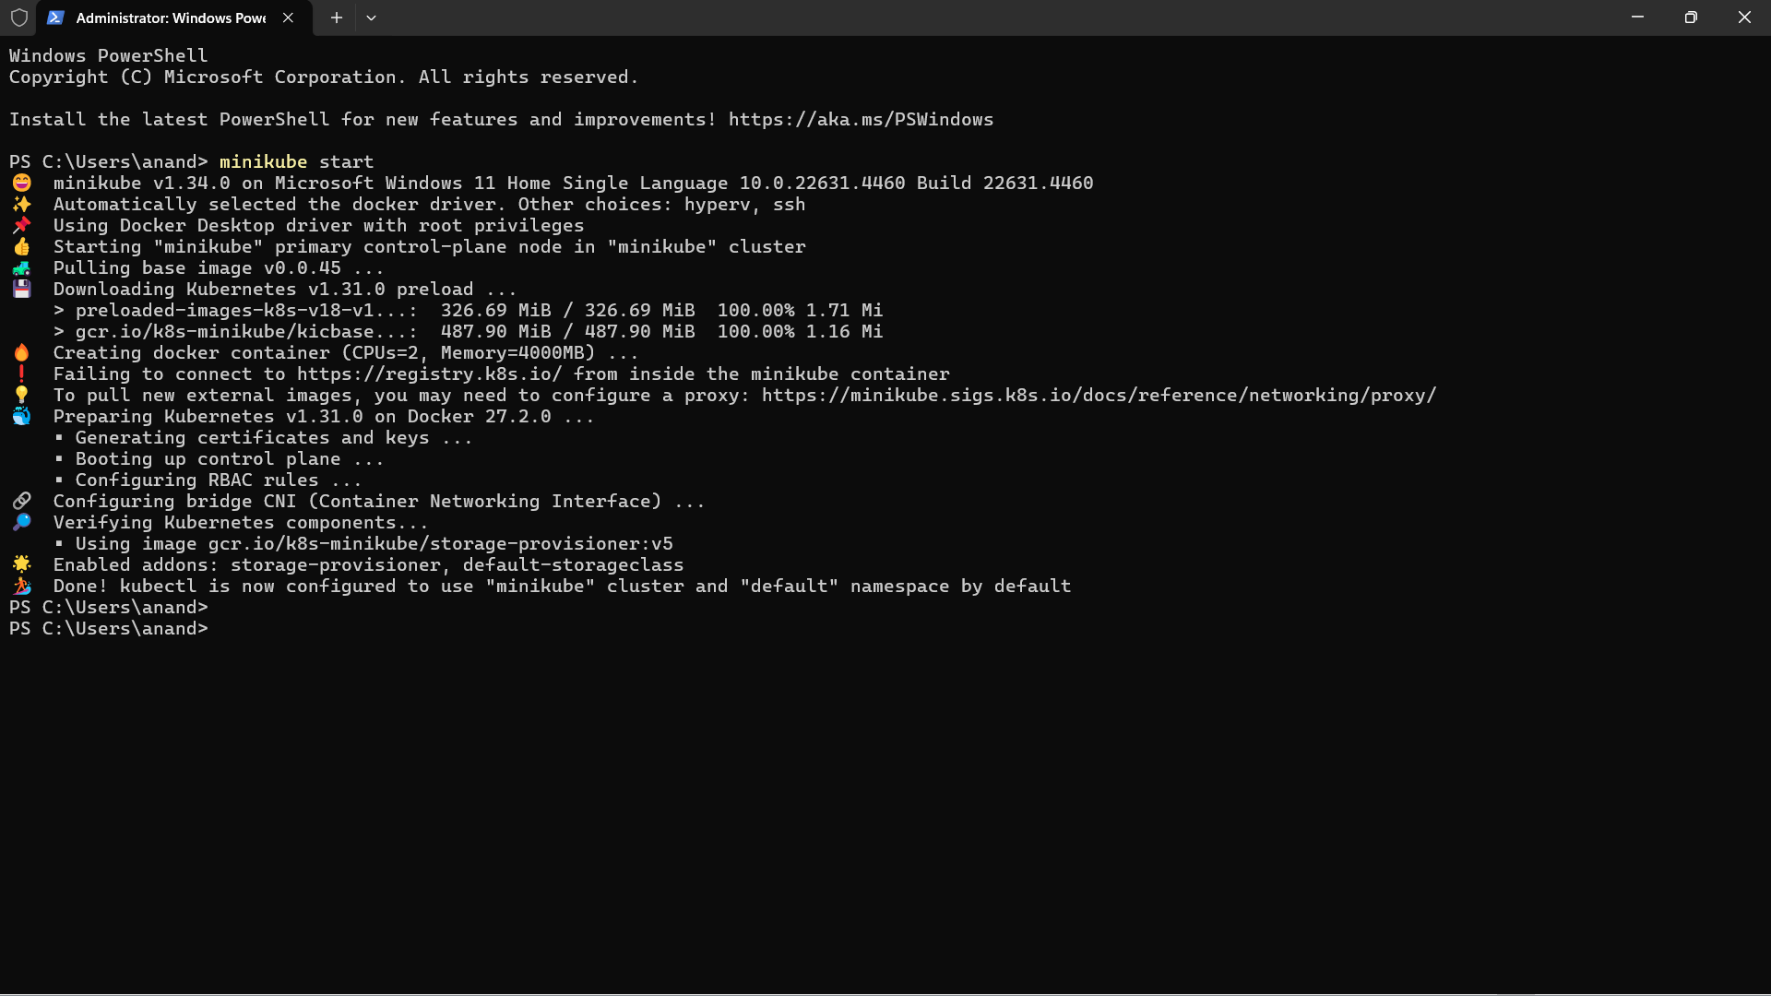

Step 4: Now, run “minikube status”. If you see the following screen, minikube is working properly!

